**1**

**Physics and Measurement**

|  |
| --- |
| **CHAPTER OUTLINE** |

1.1 Standards of Length, Mass, and Time

1.2 Modeling and Alternative Representations

1.3 Dimensional Analysis

1.4 Conversion of Units

1.5 Estimates and Order-of-Magnitude Calculations

1.6 Significant Figures

* An asterisk indicates a question or problem new to this edition.

|  |
| --- |
| **SOLUTIONS TO THINK-PAIR-SHARE AND ACTIVITIES** |

TP1.1 (a) The fourth experimental point from the top is a circle: this point lies just above the best-fit curve that passes through the point (400 cm2, 0.20 g). The interval between horizontal grid lines is 1 space = 0.05 g. An estimate from the graph shows that the circle has a vertical separation of 0.3 spaces = 0.015 g above the best-fit curve.

(b) The best-fit curve passes through 0.20 g, so the percentage difference is



(c) The best-fit curve passes through the origin and the point (600 cm2, 0.32 g). Therefore, the slope of the best-fit curve is



(d) For shapes cut from this copy paper, the mass of the cutout is proportional to its area: *m* = *aA*. The proportionality constant *a* is 5.3 g/m2.

(e) This result is to be expected if the paper has thickness and

density that are uniform within the experimental uncertainty.

(f) The slope is the areal density of the paper, its mass per unit area.]

*TP1.2 All results should be close to 2.54, representing the conversion factor 2.54 cm/in.

*TP1.3 Solution: The difference is due to the average density, which is related to the composition of the penny. Before 1982, U.S. pennies were 95% copper and 5% zinc. After that date, they are 97.5% zinc, with a coating of 2.5% copper. Both copper and zinc pennies were produced in 1982. Perhaps a measurement of the mass of a sample of 1982 pennies would be interesting.

|  |
| --- |
| **SOLUTIONS TO END-OF-CHAPTER PROBLEMS** |

Section 1.1 Standards of Length, Mass, and Time

P1.1 (a) Modeling the Earth as a sphere, we find its volume as



Its density is then



(b) This value is intermediate between the tabulated densities of aluminum and iron. Typical rocks have densities around 2000 to 3000 kg/m3. The average density of the Earth is significantly higher, so higher-density material must be down below the surface.

P1.2 (a)  where d is the diameter.

Then 

(b) 

P1.3 For either sphere the volume is  and the mass is  We divide this equation for the larger sphere by the same equation for the smaller:



Then 

**P1.4** The volume of a spherical shell can be calculated from



From the definition of density, , so



**\*P1.5**

Let us find the angle subtended by the width of the Great Wall at the height of the spacecraft orbit. From the description of a subtended angle in the problem statement, we obtain



The angle subtended by the width of the Great Wall at a height of 200 km is 3.5 × 10–5 rad, which is smaller than the normal visual acuity of the eye by about a factor of ten. Therefore, despite its great length, its width cannot be seen. In the same way, a single human hair cannot be seen from several meters away, despite its length. Your argument should be based on this calculation.]

Answer: The angle subtended by the Great Wall is less than the visual acuity of the eye.

Section 1.2 Matter and Model Building

P 1.6 Figure P1.6 suggests a right triangle where, relative to angle *θ*,its adjacent side has length *d* and its opposite side is equal to width of the river, *y*; thus,



*y* = (100 m)tan(35.0°) = 70.0 m

The width of the river is .

P1.7 From the figure, we may see that the spacing between diagonal planes is half the distance between diagonally adjacent atoms on a flat plane. This diagonal distance may be obtained from the Pythagorean

distance *L =* 0.200 nm, the diagonal planes are separated by 

Section 1.3 Dimensional Analysis

P1.8 The term *x* has dimensions of L, *a* has dimensions of  and *t* has dimensions of T. Therefore, the equation has dimensions of



The powers of L and T must be the same on each side of the equation. Therefore,

 and 

Likewise, equating terms in T, we see that *n* – 2*m* must equal 0. Thus, . The value of *k*, a dimensionless constant, .

P1.9 (a) Write out dimensions for each quantity in the equation

*vf* = *vi + ax*

The variables *vf* and *vi* are expressed in units of m/s, so

[*vf*] = [*vi*] = LT –1

The variable *a* is expressed in units of m/s2; [*a*] = LT –2

The variable *x* is expressed in meters. Therefore, [*ax*] = L2 T –2

Consider the right-hand member (RHM) of equation (a):

[RHM] = LT –1+L2 T –2

Quantities to be added must have the same dimensions. Therefore, 

(b) Write out dimensions for each quantity in the equation

*y* = (2 m) cos (*kx*)

For *y*, [*y*] = L

for 2 m, [2 m] = L

and for (*kx*), 

Therefore we can think of the quantity *kx* as an angle in radians, and we can take its cosine. The cosine itself will be a pure number with no dimensions. For the left-hand member (LHM) and the right-hand member (RHM) of the equation we have

 

These are the same, so 

P1.10 Summed terms must have the same dimensions.

(a) [X] = [*At*3] + [*Bt*]



(b) 

Section 1.4 Conversion of Units

P1.11 From Table 14.1, the density of lead is 1.13 × 104 kg/m3, so we should expect our calculated value to be close to this value. The density of water is 1.00 × 103 kg/m3, so we see that lead is about 11 times denser than water, which agrees with our experience that lead sinks.

Density is defined as  We must convert to SI units in the calculation.



Observe how we set up the unit conversion fractions to divide out the units of grams and cubic centimeters, and to make the answer come out in kilograms per cubic meter. At one step in the calculation, we note that **one million** cubic centimeters make one cubic meter. Our result is indeed close to the expected value. Since the last reported significant digit is not certain, the difference from the tabulated values is possibly due to measurement uncertainty and does not indicate a discrepancy.

P1.12 The area of the four walls is (3.6 + 3.8 + 3.6 + 3.8) m × (2.5 m) = 37 m2. Each sheet in the book has area (0.21 m)(0.28 m) = 0.059 m2. The number of sheets required for wallpaper is 37 m2/0.059 m2 = 629 sheets = 629 sheets (2 pages/1 sheet) = 1260 pages.



P1.13 The aluminum sphere must be larger in volume to compensate for its lower density. We require equal masses:



then use the volume of a sphere. By substitution,



Now solving for the unknown,



Taking the cube root, 

The aluminum sphere is 43% larger than the iron one in radius, diameter, and circumference. Volume is proportional to the cube of the linear dimension, so this excess in linear size gives it the (1.43)(1.43)(1.43) = 2.92 times larger volume it needs for equal mass.

P1.14 The mass of each sphere is 

and  Setting these masses equal,



The resulting expression shows that the radius of the aluminum sphere is directly proportional to the radius of the balancing iron sphere. The aluminum sphere is 43% larger than the iron one in radius, diameter, and circumference. Volume is proportional to the cube of the linear dimension, so this excess in linear size gives it the (1.43)3 = 2.92 times larger volume it needs for equal mass.

P1.15 We assume the paint keeps the same volume in the can and on the wall, and model the film on the wall as a rectangular solid, with its volume given by its “footprint” area, which is the area of the wall, multiplied by its thickness *t* perpendicular to this area and assumed to be uniform. Then,



The thickness of 1.5 tenths of a millimeter is comparable to the thickness of a sheet of paper, so this answer is reasonable. The film is many molecules thick.

P1.16 (a) To obtain the volume, we multiply the length, width, and height of the room, and use the conversion 1 m = 3.281 ft.

**

(b) The mass of the air is

**

The student must look up the definition of weight in the index to find

**

where the unit of N of force (weight) is newtons.

Converting newtons to pounds,



Section 1.5 Estimates and Order-of-Magnitude Calculations

P1.17 (a) We estimate the mass of the water in the bathtub. Assume the tub measures 1.3 m by 0.5 m by 0.3 m. One-half of its volume is then

*V* = (0.5)(1.3)(0.5)(0.3) = 0.10 m3

The mass of this volume of water is



(b) Pennies are now mostly zinc, but consider copper pennies filling 50% of the volume of the tub. The mass of copper required is



P1.18 Don’t reach for the telephone book or do a Google search! Think. Each full-time piano tuner must keep busy enough to earn a living. Assume a total population of 107 people. Also, let us estimate that one person in one hundred owns a piano. Assume that in one year a single piano tuner can service about 1 000 pianos (about 4 per day for 250 weekdays), and that each piano is tuned once per year.

Therefore, the number of tuners



If you did reach for an Internet directory, you would have to count. Instead, have faith in your estimate. Fermi’s own ability in making an order-of-magnitude estimate is exemplified by his measurement of the energy output of the first nuclear bomb (the Trinity test at Alamogordo, New Mexico) by observing the fall of bits of paper as the blast wave swept past his station, 14 km away from ground zero.

**P1.19**

**Solution**

Imagine movies, television shows, or theme park rides where you may have seen a spacecraft traveling through a crowded asteroid field. In reality, in such a crowded field, the asteroids would be colliding and grinding themselves down into small particles.

We will assume that the distribution of the asteroids is uniform, which is not necessarily true but will allow us to make an estimate. With this assumption, the problem can be solved with a geometric model of a doughnut.

Let us first set up the geometric model of the doughnut-shaped asteroid belt. The diagram below shows this model.

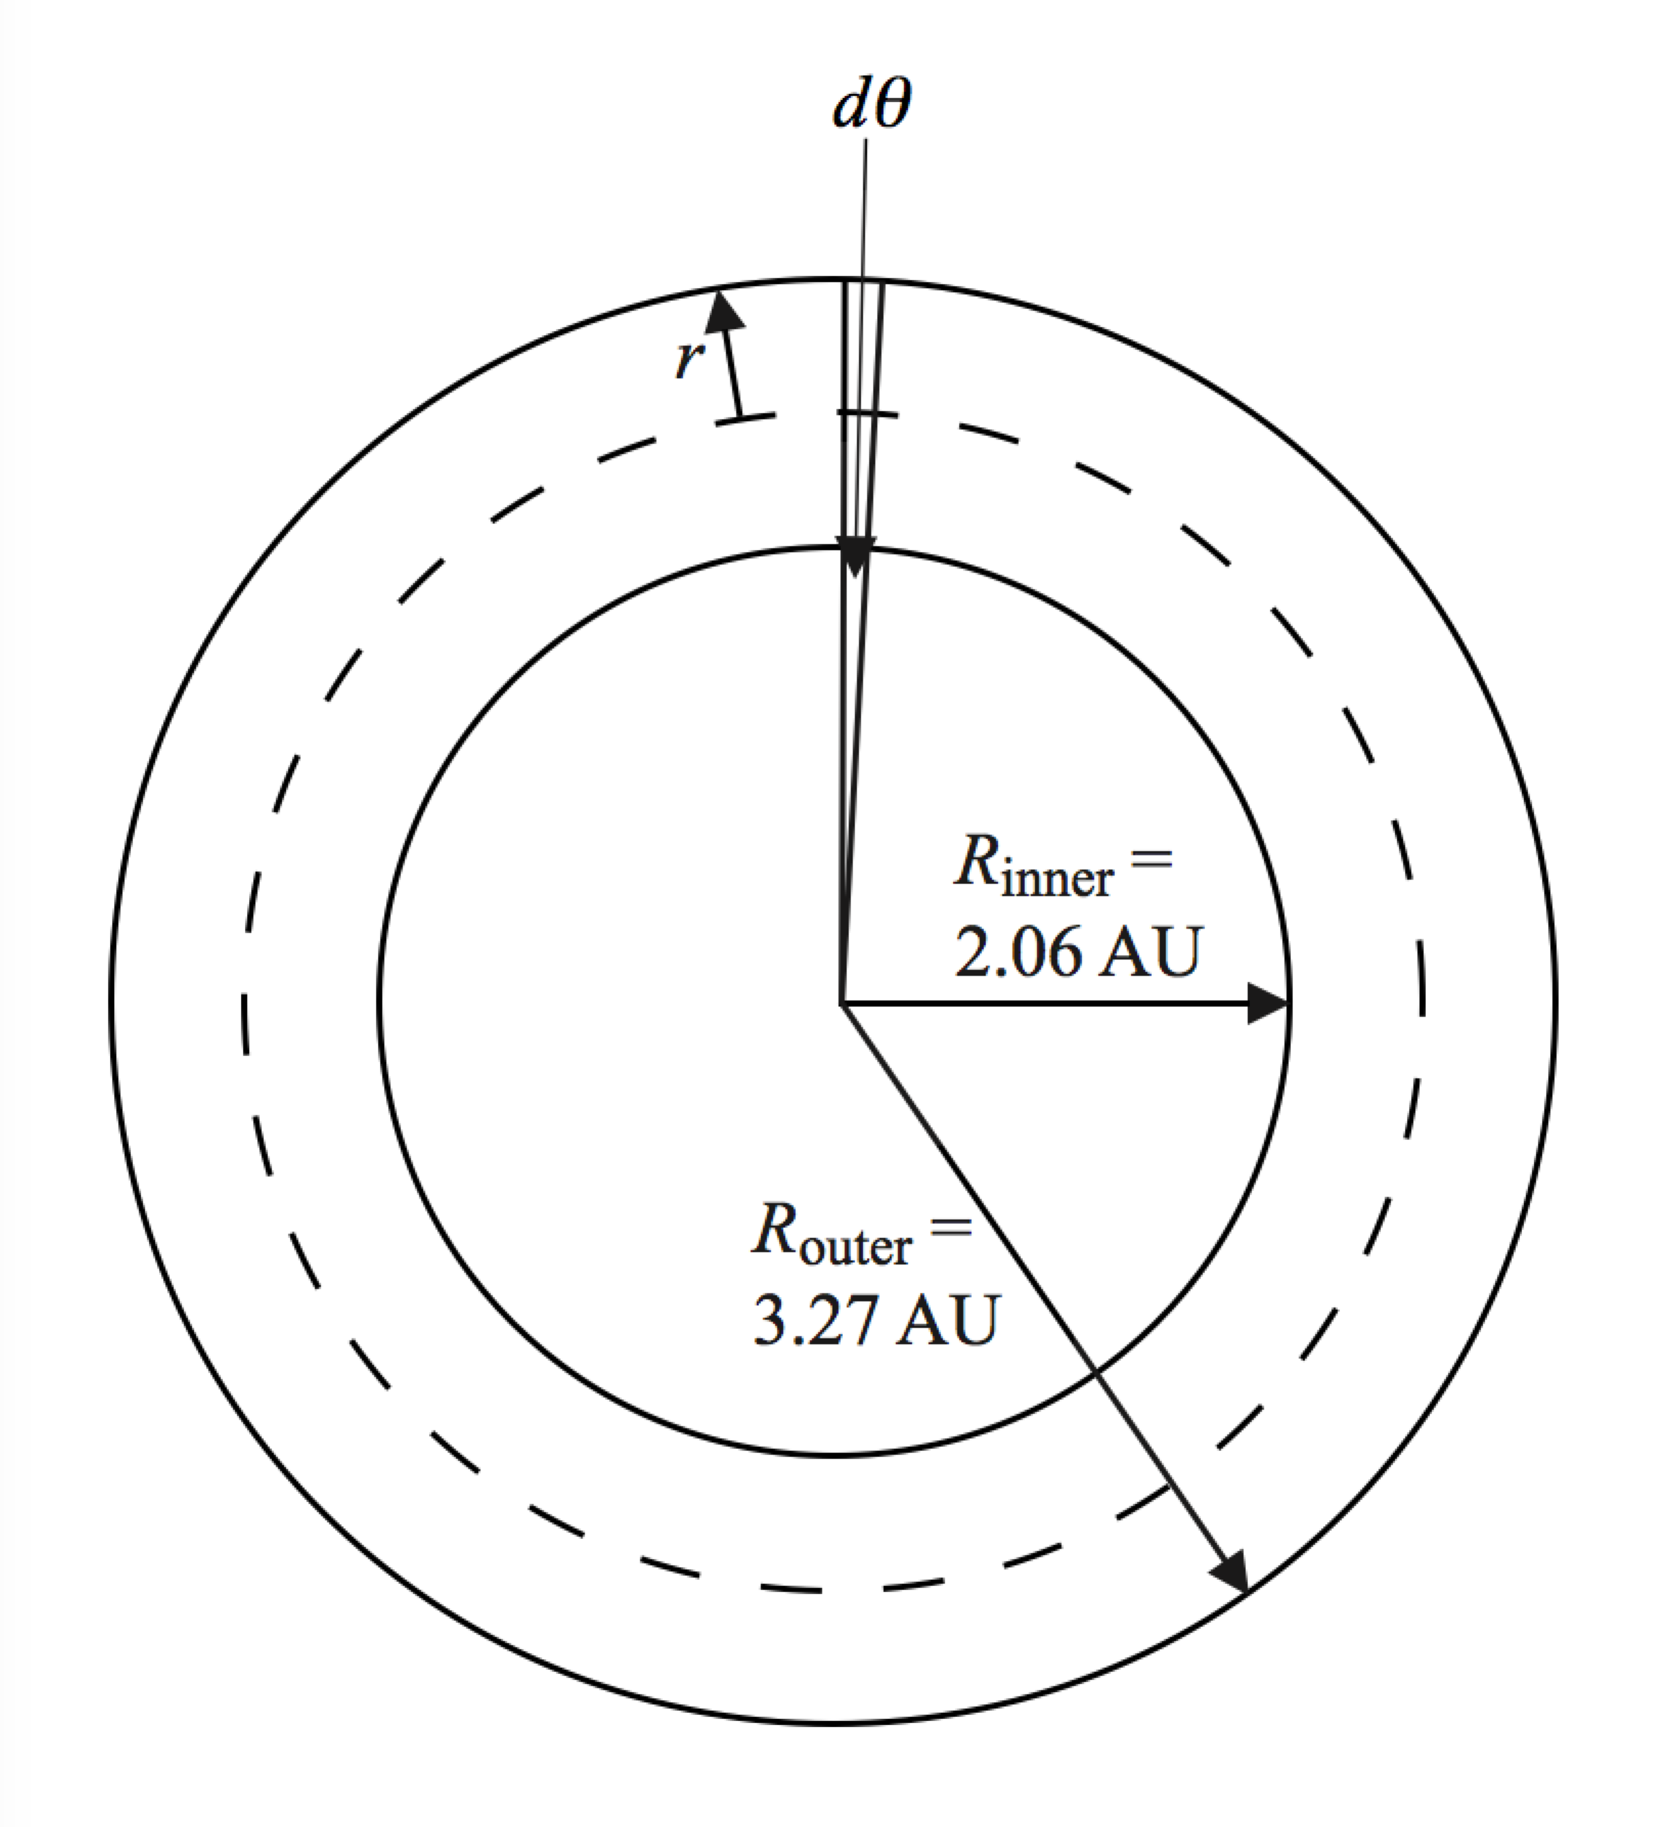

The dashed line is at the average position of the inner and outer radii and represents the path through the centers of all circular cross sections of the doughnut, which have radius *r*. The volume of the thin slice of the doughnut shown at the top of the figure is the product of the area of the circular cross section and the average width of the slice, which we take to be the width at the dashed line. Therefore,

 (1)

Integrate Equation (1) around the doughnut:



From the geometry, we see that

 (3)

Substituting Equation (3) into Equation (2),



Divide the number *N* of asteroids in this region by this volume to find the number of asteroids per unit volume:



Substitute numerical values:



Convert to metric units:



Taking the reciprocal, we find that, on average, the volume associated with one asteroid is



Taking a cube root of this result, we see that an average asteroid occupies a volume equivalent to a cube with side length 4.01 × 108 m, or 401 000 km, which is more than 30 times the diameter of the earth. This is an enormous volume compared to any conceivable spacecraft. There is very little chance that you would be near an asteroid of radius 100 m or more, not to mention fighting your way through a crowded field of them. Despite the fact that there is a large number of asteroids, they are distributed through a tremendous volume of space.]

*Answer*: The average distance between asteroids in the asteroid belt is about 400 000 km.

Section 1.6 Significant Figures

P1.20 (a) The ± 0.2 following the 78.9 expresses uncertainty in the last digit. Therefore, there are  significant figures in 78.9 ± 0.2.

(b) Scientific notation is often used to remove the ambiguity of the number of significant figures in a number. Therefore, all the digits in 3.788 are significant, and 3.788 × 109 has significant figures.

(c) Similarly, 2.46 has three significant figures, therefore 2.46 × 10–6 has  significant figures.

(d) Zeros used to position the decimal point are not significant. Therefore 0.005 3 has significant figures.

Uncertainty in a measurement can be the result of a number of factors, including the skill of the person doing the measurements, the precision and the quality of the instrument used, and the number of measurements made.

P1.21 We work to nine significant digits:



P1.22 We are given the ratio of the masses and radii of the planets Uranus and Neptune:



The definition of density is  for a sphere, and we assume the planets have a spherical shape.

We know  Compare densities:



which gives



P1.23 Let *o* represent the number of ordinary cars and *s* the number of sport utility vehicles. We know *o* = *s* + 0.947*s* = 1.947*s*, and *o* = *s* + 18.

We eliminate *o* by substitution:



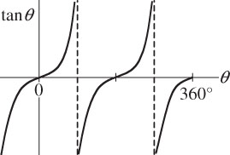

P1.24 We require



**ans. Fig. P1.24**

For tan–1(–3) = arctan(–3), your calculator may return –71.6°, but this angle is not between 0° and 360° as the problem   
requires. The tangent function is negative   
in the second quadrant (between 90° and 180°) and in the fourth quadrant (from 270° to 360°). The solutions to the equation are then



P1.25 Let *s* represent the number of sparrows and *m* the number of more interesting birds. We know *s*/*m* = 2.25 and *s* + *m* = 91.

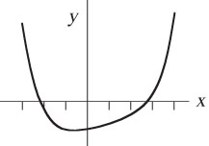 We eliminate *m* by substitution:





P1.26 For those who are not familiar with solving equations numerically, we provide a detailed solution. It goes beyond proving that the suggested answer works.

The equation 2*x*4 – 3*x*3 + 5*x* – 70 = 0 is quartic, so we do not attempt to solve it with algebra. To find how many real solutions the equation has and to estimate them, we graph the expression:

|  |  |  |  |  |  |  |  |  |
| --- | --- | --- | --- | --- | --- | --- | --- | --- |
| *x* | –3 | –2 | –1 | 0 | 1 | 2 | 3 | 4 |
| *y =* 2*x*4 *–* 3*x*3*+* 5*x* –70 | 158 | –24 | –70 | –70 | –66 | –52 | 26 | 270 |

We see that the equation *y* = 0 has two roots, one around *x* = –2.2 and the other near *x* = +2.7. To home in on the first of these solutions we compute in sequence:

When *x* = –2.2, *y* = –2.20. The root must be between *x* = –2.2 and *x* = –3. When *x* = –2.3, *y* = 11.0. The root is between *x* = –2.2 and *x* = –2.3. When *x* = –2.23, *y* = 1.58. The root is between *x* = –2.20 and *x* = –2.23. When *x* = –2.22, *y* = 0.301. The root is between *x* = –2.20 and –2.22. When *x* = –2.215, *y* = –0.331. The root is between *x* = –2.215 and –2.22. We could next try *x* = –2.218, but we already know to three-digit precision that the root is *x* = –2.22.

**P1.27** Use substitution to solve simultaneous equations. We substitute *p* = 3*q* into each of the other two equations to eliminate *p*:



These simplify to 

We substitute the upper relation into the lower equation to eliminate *s*:



We now have the ratio of *t* to 

**P1.28** First, solve the given equation for 



(a) Making *d* three times larger with *d*2 in the bottom of the fraction makes 

(b) 

(c) 

(d) From the last version of the equation, the slope is  Note that this quantity is constant as both ∆*t* and *d* vary.

Additional Problems

**P1.29** It is desired to find the distance *x* such that



(i.e., such that *x* is the same multiple of 100 m as the multiple that   
1 000 m is of *x*). Thus, it is seen that

*x*2 = (100 m)(1 000 m) = 1.00 × 105 m2

and therefore



**P1.30** (a) A Google search yields the following dimensions of the intestinal tract:

small intestines: length ≅ 20 ft ≅ 6 m, diameter ≅ 1.5 in ≅ 4 cm

large intestines: length ≅ 5 ft ≅ 1.5 m, diameter ≅ 2.5 in ≅ 6 cm

Treat the intestines as two cylinders: the volume of a cylinder of diameter *d* and length *L* is 

The volume of the intestinal tract is



Assuming 1% of this volume is occupied by bacteria, the volume of bacteria is



Treating a bacterium as a cube of side *L* = 10–6 m, the volume of one bacterium is about *L*3 = 10–18 m3. The number of bacteria in the intestinal tract is about



(b) The large number of bacteria suggests they must be  otherwise the body would have developed methods a long time ago to reduce their number. It is well known that certain types of bacteria in the intestinal tract are beneficial: they aid digestion, as well as prevent dangerous bacteria from flourishing in the intestines.

**P1.31** The volume of the galaxy is



If the distance between stars is 4 × 1016, then there is one star in a volume on the order of



The number of stars is about 

**P1.32** Assume the winner counts one dollar per second, and the winner tries to maintain the count without stopping. The time interval required for the task would be





**P1.33** Answers may vary depending on assumptions:

typical length of bacterium: *L* = 10–6 m

typical volume of bacterium: *L*3 = 10–18 m3

surface area of Earth: 

(a) If we assume the bacteria are found to a depth *d* = 1000 m below Earth’s surface, the volume of Earth containing bacteria is about



If we assume an average of 1000 bacteria in every 1 mm3 of volume, then the number of bacteria is



(b) Assuming a bacterium is basically composed of water, the total mass is



**P1.34** (a) The mass is equal to the mass of a sphere of radius 2.6 cm and density 4.7 g/cm3, minus the mass of a sphere of radius *a* and density 4.7 g/cm3, plus the mass of a sphere of radius *a* and density 1.23 g/cm3.



(b) The mass is maximum for .

(c) 

(d) This is the mass of the uniform sphere we considered in the first term of the calculation.

(e) 

**P1.35** The rate of volume increase is



(a) 

(b) The rate of increase of the balloon’s radius is



(c) 

**P1.36** The table below shows *α* in degrees, *α* in radians, tan(*α*), and sin(*α*) for angles from 15.0° to 31.1°:

|  |  |  |  |  |
| --- | --- | --- | --- | --- |
| *α*′ (deg) | *α* (rad) | tan(*α*) | sin(*α*) | difference between  *α* and tan *α* |
| 15.0 | 0.262 | 0.268 | 0.259 | 2.30% |
| 20.0 | 0.349 | 0.364 | 0.342 | 4.09% |
| 30.0 | 0.524 | 0.577 | 0.500 | 9.32% |
| 33.0 | 0.576 | 0.649 | 0.545 | 11.3% |
| 31.0 | 0.541 | 0.601 | 0.515 | 9.95% |
| 31.1 | 0.543 | 0.603 | 0.516 | 10.02% |

We see that *α* in radians, tan(*α*), and sin(*α*) start out together from zero and diverge only slightly in value for small angles. Thus  is the largest angle for which 

P1.37 We write “millions of cubic feet” as 106 ft3, and use the given units of time and volume to assign units to the equation.



To convert the units to seconds, use



to obtain



or



where *V* is in cubic feet and *t* is in seconds. The coefficient of the first term is the volume rate of flow of gas at the beginning of the month. The second term’s coefficient is related to how much the rate of flow increases every second.

**P1.38** (a) and (b), the two triangles are shown.

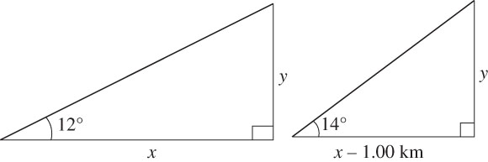

**ans. Fig. P1.70(a) ans. Fig. P1.70(b)**

(c) From the triangles,



and 

(d) Equating the two expressions for *y*, we solve to find 

Challenge Problems

**P1.39** The geometry of the problem is shown below.

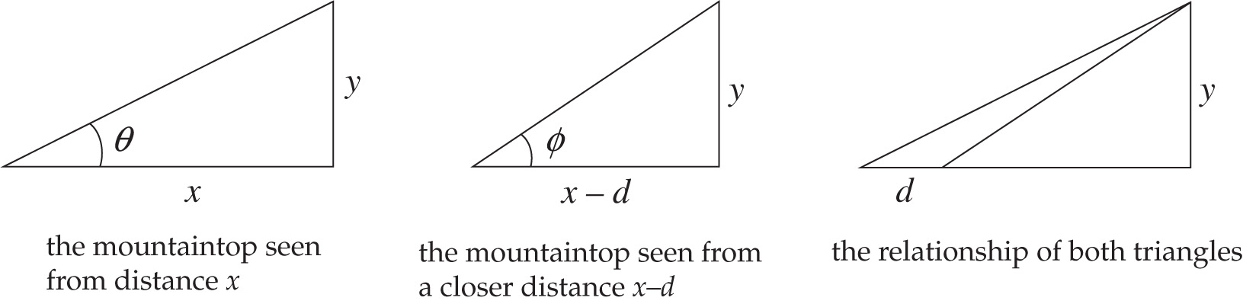

**ANS. FIG. P1.39**

From the triangles in ANS. FIG. P1.72,



and



Equate these two expressions for *y* and solve for *x*:



Take the expression for *x* and substitute it into either expression for *y*:



|  |
| --- |
| **ANSWERS TO QUICK_QUIZZES** |

1. (a)
2. False
3. (b)

|  |
| --- |
| **ANSWERS TO EVEN-NUMBERED PROBLEMS** |

P1.2 (a) 2.3 × 1017 kg/m3; (b) 1.0 × 1013 times the density of osmium

**P1.4** 

P1.6 70.0m

P1.8 The value of *k*, a dimensionless constant cannot be obtained by dimensional analysis

P1.10 (a) [A] = L/T3 and [B] = L/T; (b) L/T

P1.12 The number of pages in Volume 1 is sufficient

P1.14 *r*Fe(1.43)

P1.16 (a) 3.39 × 105 ft3; (b) 2.54 × 104 lb

P1.18 100 tuners

P1.20 (a) 3; (b) 4; (c) 3; (d) 2

P1.22 (a)  (b)  (c) 1.03 h

P1.24 288°; 108°

P1.26 See P1.26 for complete description.

P1.28 (a) nine times smaller; (b) Δ*t* is inversely proportional to the square of *d*; (c) Plot Δt on the vertical axis and 1/*d*2 on the horizontal axis;   
(d) 

P1.30 (a) 1014 bacteria; (b) beneficial

P1.32 The scenario has the contestants succeeding on the whole. But the calculation shows that is impossible. It just takes too long!

P1.34 (a) m = 346 g − (14.5 g/cm3)*a*3; (b) a = 0; (c) 346 g; (d) yes; (e) no change

P1.36 31.0°

P1.38 (a-b) see ANS. FIG. P1.38 (a) and P1.38 (b); (c) *y* = *x* tan12.0° and   
*y* = (*x* − 1.00 km) tan14.0°; (d) *y* = 1.44 km